Privacy Issues in IOT
For HealthCare Systems using Mannasim Simulation

Muhammad Fawad Jawaid Malik, Shoaib Ahmed, Syed Muhammad Zohair Naqvi, Zohaib Masood, Faraz Idris
Computer Science Department
National University of Computer and Emerging Sciences, Karachi.

Abstract — There is a great risk of a number of threats especially for wireless networks which can be more vulnerable due to its invisible feature. In recent years, hospitals also employ wireless Advanced Science and Technology SERSC communication systems as other enterprises, and the hospitals maintain many personal details for the medical purpose such as patient’s medical history. For that purpose we have discussed the working of Mannasim. And then we have discussed attacks in Mannasim. There are two types of attacks Jamming and Node Tampering.
Keywords—jamming, node tampering

Introduction
Healthcare systems use a set of interconnected devices to create an IoT network which devoted to healthcare monitoring system. One of the main challenges is to apply RFID system in ubiquitous healthcare system with embedded sensor modules based on IoT. Due to limited resources of sensor nodes, certain strategies and mechanisms are required to ensure adequate Advanced Science and Technology Letters.
To deal with several security challenges as well as growth in diverse community in an interconnected network, we need a security framework to manage diverse processing requirements and control capabilities. The purpose of the framework design is to meet the needs of new e-health security challenges. To ensure a global system, end-to-end perspective system can uncover unintended threats that may not be available at the individual’ element level, we need to have a national level protection standard to meet the emerging e-healthcare needs. There is a great risk of a number of threats especially for wireless networks which can be more vulnerable due to its invisible feature. The formatter will need to create these components, incorporating the applicable criteria that follow.

Problem Statement
There is a great risk of a number of threats especially for wireless networks which can be more vulnerable due to its invisible feature. In recent years, hospitals also employ wireless Advanced Science and Technology SERSC communication systems as other enterprises, and the hospitals maintain many personal details for the medical purpose such as patient’s medical history. However, only a few hospitals are aware of the security issues because their working process is mainly focused on emergency than security matters. This may result in a security incident such as information leakage.

Literature Review
We have gone through some of the papers and articles related to Privacy Issues in IOT. An extensive researched has been done in this field. The editor in chief of Georgia Institute of Technology, Ian Akyildiz states in one of his article that Recent advances in information and communication technologies and embedded systems have given rise to a new disruptive technology: the Internet of Things (IoT). This major development will lead to major changes in usage and to a transformation of the technological ecosystem in all its complexity.

IoT will allow people and objects in the physical world as well as data and virtual environments to interact with each other so as to create smart environments such as smart transport systems, smart cities, smart health, smart energy, etc., as part of a prosperous digital society. IoT is likely to improve the quality of people’s lives, create new markets and new jobs, increase economic growth and be an impetus for competition.

However, IoT raises important questions and introduces new challenges for the security of systems and processes and the privacy of individuals. Some IoT applications are tightly linked to sensitive infrastructures and strategic services such as the distribution of water and electricity and the surveillance of assets. Other applications handle sensitive information about people, such as their location and movements, or their health and purchasing preferences. Confidence in and acceptance of IoT will depend on the protection it provides to people’s privacy and the levels of security it guarantees to systems and processes.

IoT will enable objects to become active participants: these objects will be able to recognize events and changes in their environment and to sense and react autonomously without human intervention. Introducing objects into the control processes makes IoT security very difficult to address. Indeed, the Internet of Things is a complex system in which people interact with the technological ecosystem based on smart objects through complex processes. The interactions of these four IoT components: persons, intelligent objects, technological ecosystem, and processes highlight a systemic and cognitive dimension to the security of IoT. The interaction of people with the technological ecosystem requires the protection of their privacy. Similarly, their interaction with control processes requires to guaranteeing their safety. Processes must ensure their reliability and realize the objectives for which they are designed.

The move towards a greater autonomy for objects will bring the security of technologies and processes and the privacy of individuals into sharper focus. Furthermore, in parallel with the increasing autonomy of objects to perceive and act on the environment, IoT security should move towards a greater autonomy in perceiving threats and reacting to attacks.

A variety of IoT applications have a differences industry standards and related specifications. Unified IoT structure has not yet formed. However, to enact the IoT security standards, many organizations have issued standards such as IEEE, ETSI, etc. It gives the development of the IoT security standards [5, 6]. Most of existing IoT solutions is independent small network, there are relatively few exploits which can be
attacked. With the sustained development of IoT, the small networks will merge into a large network. By then it would be more difficult to ensure the security. These security problems would be the key factor to decide the development of IoT [7]. Kai Zhao and Lina Ge analyzed a survey on the Internet of Things security. Developing RFID technology in the healthcare industry for promoting patient’s The Internet of
Things is a new network to realize the connection of any things, anytime and anywhere. Its infrastructure is divided into three layers: perceptive layer, transport layer and processing layer. The perceptive layer is to identify and apperceive things, including label, camera, sensors and GPS etc., the transport layer is to transport and store data, and the processing layer is about information drawing, data mining etc. Xin Bai, et al., analyzed the public security techniques of the Internet of Things, including IOT-MW (Internet of Things-Middleware), encryption, decryption, secret key management, privacy homomorphism, and access control etc. especially the
cryptograph query [8]. Biplob R. Ray, et al, analyzed scalable RFID security framework and protocol for supporting Internet of Things. They proposed a novel identiﬁcation technique based on a hybrid approach (group-based approach and
collaborative approach) and security check handoff (SCH) for RFID systems with mobility. The proposed protocol provides customizability and adaptability as well as ensuring the secure and scalable deployment of an RFID system to support a robust distributed structure such as the IoT [9].

Proposed Solution
In order to apply RFID system in healthcare system, enhanced secure mobile health system should be developed using wireless communication to solve security problem. This system includes two-way interactive authentication process, sensor technology, and health informatics. Especially, sensor technologies for identification play an important role in intelligent services using network communications. The personnel private data would be collected through wireless monitoring devices.
As a first step of security, well-organized authentication processes based on network should be prepared against various threats for wireless networks. The security framework focuses on mechanisms for the distribution and establishment of secret keys that allow bootstrapping secure links, access control to the sensed information, and privacy-aware management of the medical data and user's identities. Centralized and distributed security solutions are combined in order to provide enough balance between performance and security requirements. Network security and management play an important role in each level. Then we should analyze the security features in each layer such as perceptual layer, network layer, support layer and application layer. Now, we should take into account to look into the state of research for the security requirements such as encryption mechanism, communication security, protecting sensor data, and cryptographic algorithms in communication channel.

Methodology
We proposed a suitable wireless security mechanism for the hospital. To begin with, the organizational characteristics of the hospital should be analyzed before selecting the wireless mechanism. With mobile devices in HIS, the staff will be able to access EMR systems to view or update patient’s medical records. The usual methods to provide security at the network level, in the case of packet networks, are datagram encapsulation. One of the most common technologies used to ensure secure communications in the Internet is the Internet Protocol Security (IPsec) protocol. IPsec is an end-to-end security scheme operating in the IP stack, enabling both authentication and confidentiality.

Architecture Of Health Care System
To deal with existing security challenges as well as growth in diverse community in an interconnected network, we need a security framework to manage diverse processing requirements and control capabilities. The purpose of the framework design is to meet the needs of new e-health security challenges. To ensure a global system, end-to-end perspective system can uncover unintended threats that may not be available at the individual’ element level, we need to have a national level protection standard to meet the emerging e-healthcare needs [10]. As a first step of security, well-organized authentication processes based on network should be prepared against various threats especially for wireless networks which can be more vulnerable due to its invisible feature. In recent years, hospitals also employ wireless
communication systems as other enterprises, and the hospitals maintain many personal details for the medical purpose such as patient’s medical history. However, only a few hospitals are aware of the security issues because their working process is mainly focused on emergency than security matters. This may result in a security incident such as information leakage. Therefore, we proposed a suitable wireless security mechanism for the hospital. To begin with, the organizational characteristics of the hospital should be analyzed before selecting the wireless mechanism. With mobile devices in HIS, the staff will be able to access EMR systems to view or update patient’s medical records. The usual methods to provide security at the network level, in the case of packet networks, are datagram encapsulation. One of the most common technologies used to ensure secure communications in the Internet is the Internet Protocol Security (IPsec) protocol. IPsec is an end-to-end security scheme operating in the IP stack, enabling both authentication and confidentiality [11]. Although IPsec ensures these security services to any protocol in the upper layers, it introduces some overhead that will reduce throughput. The security framework focuses on mechanisms for the distribution and establishment of secret keys that allow bootstrapping secure links, access control to the sensed information, and privacy-aware management of the medical data and user's identities. We combine centralized and distributed security solutions in order to provide an adequate balance between performance and security requirements. Network security and management play an important role in above each level. Then we should analyze the security features in each layer such as perceptual layer, network layer, support layer and application layer. Now, we should take into account to look into the state of research for the security requirements such as encryption mechanism, communication security, protecting sensor data, and cryptographic algorithms in communication channel [12].

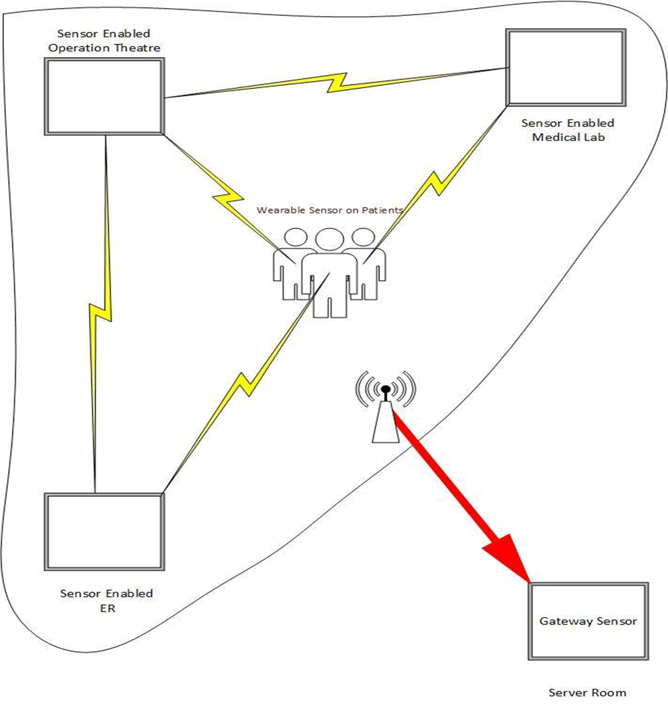

Physical Attacks
Dos attack on the physical layer of Wireless sensor network carries out different operation like transmission and reception of data. So attack on this layer will cause major loss of data, which can be done by two types

1) Jamming.
2) Node tampering.

Jamming
Jamming can be done by overcrowding or sealing the connection between the nodes, so that they can’t communicate and send data to each other.

Node Tampering
Node tampering can be done by attacking to the nodes and make their data fault or corrupt to provide wrong information.

In Mannasim, jamming can be implemented by sending continuous garbage data to a node or changing battery data of a node, i.e. decreasing battery power to shut down a node. While node tampering can be done by explicitly setting node data using a script which will override the data of a node in simulation.

Physical Attacks In Health Care Systems

Node Jamming
- Any intruder can enter into the network and can physically attack.
- By running some script attacker can physically jam the network.
- Attacker can shut down the nodes or can break the connections of the nodes.
- by the communication gap between nodes no nodes can send data to the other node hence data can’t reach to the gateway.
- No new data update to the database.

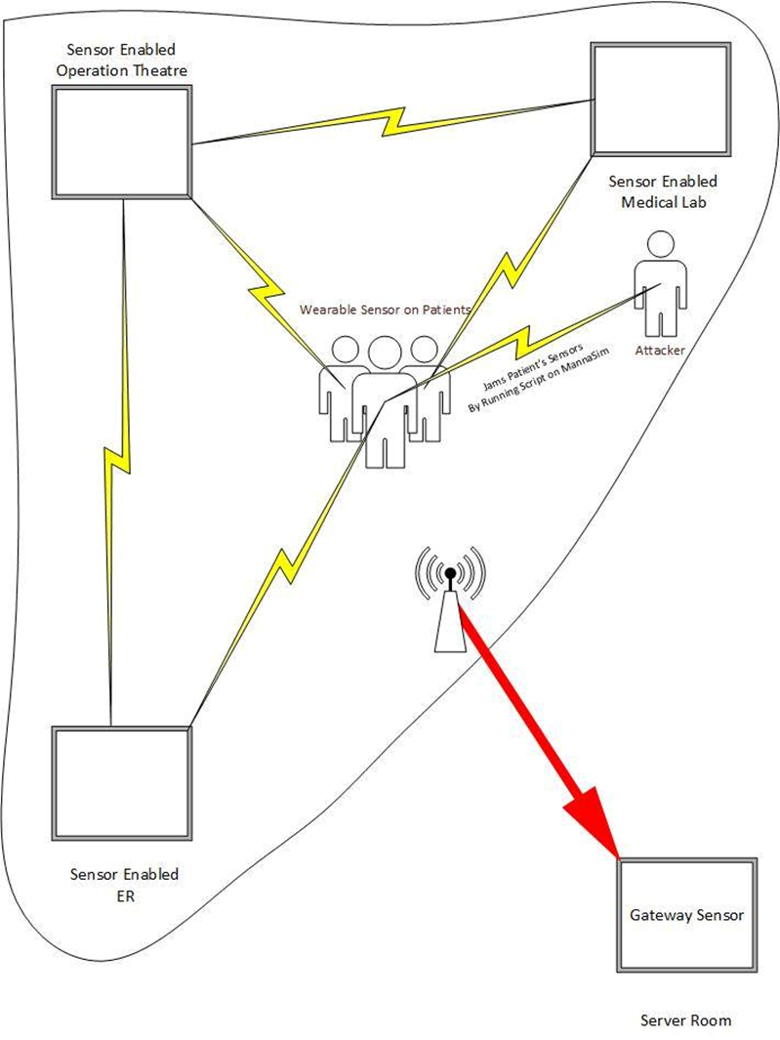

Node Tampering
- Attacker can move into the network and by running some script access the data of the nodes.
- By the availability of the data attacker has the choice to temper the data.
- Attacker can alter the critical data, the data of patients which is very critical .

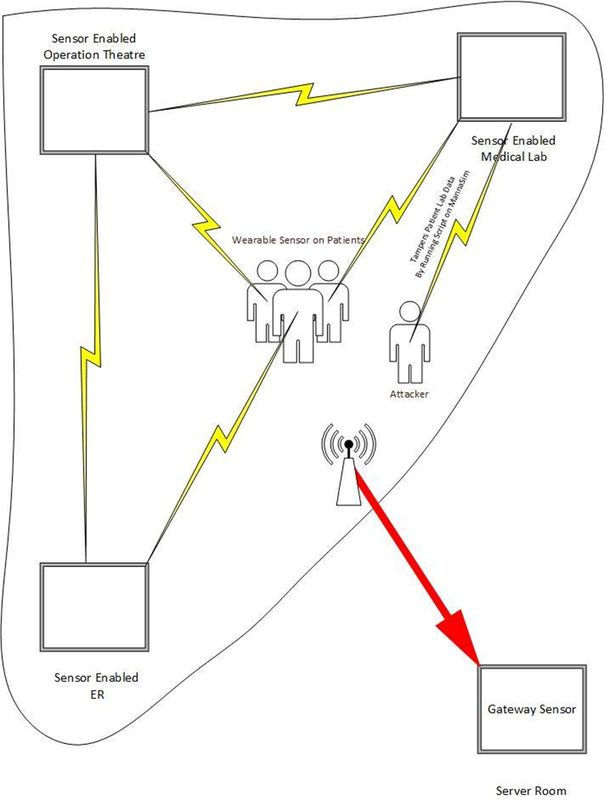

Conclusion
The development of IoT security is an important part of IoT. This paper respectively explains some problems and solutions from each layer of IoT security structure. Optimized security protocols and mechanisms are employed for the high performance and security in u-healthcare system. In this paper, security issues on the IoT construction layers is analyzed and appropriate coping strategies are given to build a safe IoT construction so that the IoT can protect revealing healthy and stable development in practical applications. A challenge in the near future will be the integration of IoT with security protocols to the hospital environment. Developing a security protocol in u-healthcare environment is major concern in future.

References

- Mannasim Framework http://www.mannasim.dcc.ufmg.br/download.htm
- Uday Kumar, Sugata Sanyal, Survey of Security and Privacy Issues of Internet of Things Tuhin Borgohain
- S. Sicari, A. Rizzardi, L.A. Grieco, A. Coen-Porisini Security, privacy and trust in Internet of Things: The road ahead

- Jeonggil Ko, et al, “Wireless Sensor Networks for Healthcare”, Proceedings of the IEEE, v.98, n.11, pp. 1947-1960 (2010)
- Lenka Lhotska, et al, “Security Recommendations for Implementation in Distributed Healthcare Systems”, ICCST2008, pp.76-83 (2008)
- Kai Zhao and Lina Ge, "A Survey on the Internet of Things Security", 2013 Ninth International Conference on Computational Intelligence and Security, pp.663-667, (2013)
- Xin Bai, Zhengzhou and Hongyan Yan, "Study and Design of the Safe HIS on the Internet of Things",2011 Fourth International Symposium on Computational Intelligence and Design, pp.174-176, (2011)
- Biplob R. Ray, Jemal Abawajy and Morshed Chowdhury, "Scalable RFID security framework and protocol supporting Internet of Things", Computer Networks 67, pp.89–103, (2014)
- Azzedine Boukerche and Yonglin Ren, “A Secure Mobile Healthcare System Using Trust-based Multicast Scheme”, IEEE Journal on Selected Areas in Communications, v.27, n.4, pp.387-397, May (2009)
- Wiem Tounsi, et al, “Securing the Communications of Home Health Care System based on RFID Sensor Networks”, 8th Annual Communication Network and Services Research Conference, pp.284-291 (2010)
- Yanjun Zuo, Survivable RFID Systems: Issues, Challenges, and Techniques”, IEEE Transactions on Systems, Man, and Cybernetics- part C: Applications and Reviews, v.40, n.4, pp.406-418. July (2010)

